|  |  |
| --- | --- |
| ENGR 325 LAB 2  Interfacing with LCD Devices Systems.  12TH Sept 2019. | Abstract  This lab focusses on working with LCD devices, using the Signal Tap Logic Analyzer tool, and writing C language programs for the NIOS processor system using function calls provided by the Hardware Abstraction Layer (HAL) (or device drivers).  Daniel Ackuaku |

*Part 1: Printout of your C code that was written to display the “hello…”*

#include "altera_up_avalon_character_lcd.h"

int main(void)

{

alt_up_character_lcd_dev * char_lcd_dev;

// open the Character LCD port

char_lcd_dev = alt_up_character_lcd_open_dev ("/dev/Char_LCD_16x2");

if ( char_lcd_dev == NULL)

alt_printf ("Error: could not open character LCD device\n");

else

alt_printf ("Opened character LCD device\n");

/* Initialize the character display */

alt_up_character_lcd_init (char_lcd_dev);

/* Write "Welcome to" in the first row */

alt_up_character_lcd_string(char_lcd_dev, "Hello I'm");

/* Write "the DE2 board" in the second row */

char second_row[] = "is Daniel :)\0";

alt_up_character_lcd_set_cursor_pos(char_lcd_dev, 0, 1);

alt_up_character_lcd_string(char_lcd_dev, second_row);

}

*Part 3: Analyzing the effect of the alt_printf() function.*

The alt_printf () function call dramatically increases the size of the program in addition to using up a large portion of the heap. The code was compiled and run with and without the alt_printf () and the results are as follows.

*Before*:

14 KBytes program size (code + initialized data).

Info: 6680 Bytes free for stack + heap.

*After*:

4848 Bytes program size (code + initialized data).

Info: 17 KBytes free for stack + heap.

*Part 4:* *Screen-capture printouts of the signal tap analysis.*

When LCD_RW is low and the LCD_EN is high, a new character is written into the LCD_DATA register. The circled portion of the graph highlights when this happens and how the LCD_DATA value changes from a Null pointer to the ASCII value of the displayed character.

The smaple occurs on 5 MHz clock, which means each every 2*10-7 secs a sample occurs. Using the signal tap tool, it was determined that the distance between two subsequent characters in the LCD _DATA registers were 137 samples. Which puts the time taken between these two signals as the product of 2*10-7 secs per samples and 137 samples = 2.74 *10-5 secs.

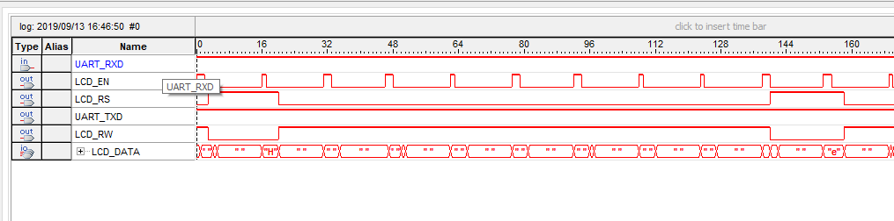

*Part 5: Analysis of the signal tap data.*

